***Name:*** ................................................................ ***Klasse:*** …………

**4.1.1 Arbeitsblatt: Die wichtigsten Faltengebirge**

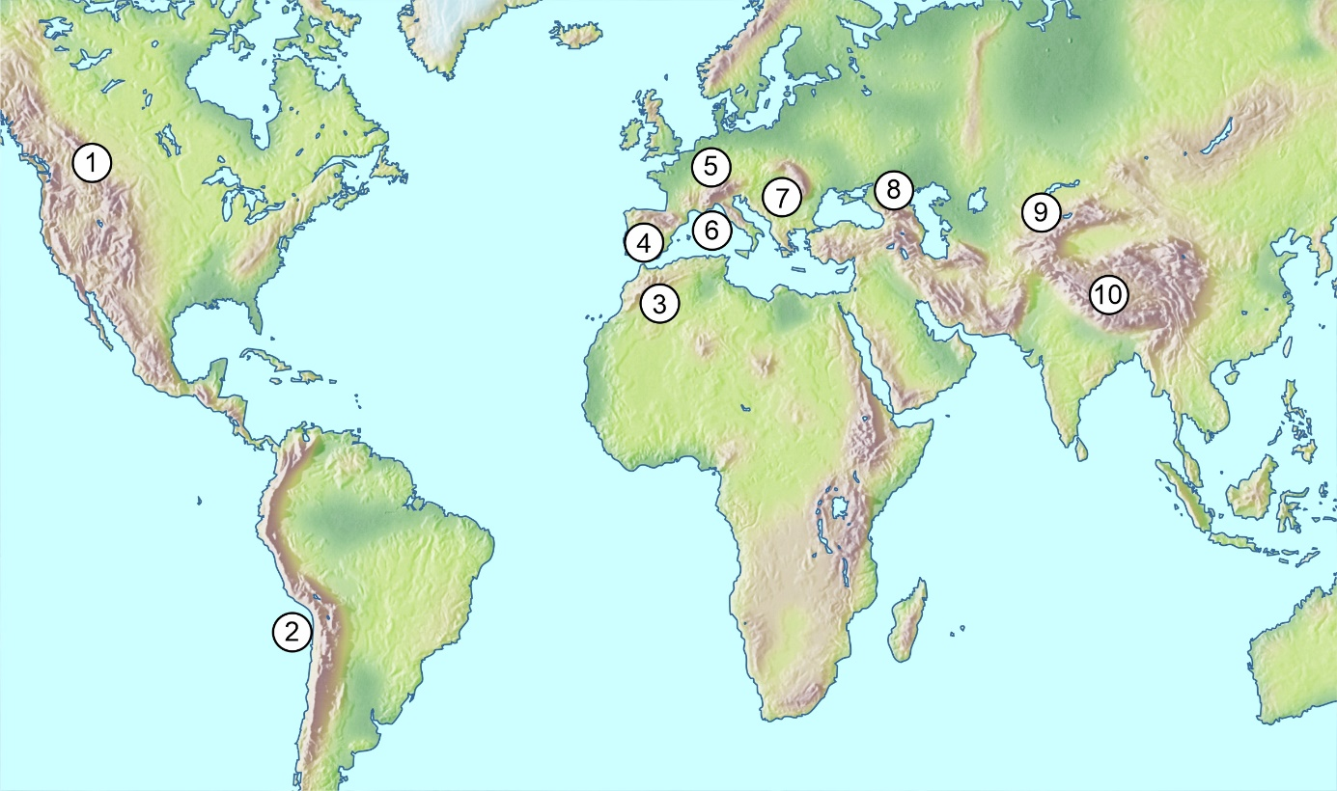

Quelle: WBF 2021; Physische Karte, verschiedene Atlanten  
Kartenvorlage: Mountain High Maps® Copyright © 1993 Digital Wisdom®, Inc.

|  |  |  |  |  |  |  |  |  |  |  |  |  |  |  |  |  |  |  |  |  |  |  |  |  |
| --- | --- | --- | --- | --- | --- | --- | --- | --- | --- | --- | --- | --- | --- | --- | --- | --- | --- | --- | --- | --- | --- | --- | --- | --- |
|  |  |  | c |  |  |  |  |  |  |  | **4** |  |  |  |  |  |  |  |  |  |  |  |  |  |

|  |  |  |  |  |  |  |  |  |  |  |  |  |  |  |  |  |  |  |  |  |  |  |  |  |
| --- | --- | --- | --- | --- | --- | --- | --- | --- | --- | --- | --- | --- | --- | --- | --- | --- | --- | --- | --- | --- | --- | --- | --- | --- |
|  |  |  |  | **6** |  |  |  |  |  |  |  |  |  | **5** | **2** |  |  |  |  | **8** |  |  |  | **11** |

|  |  |  |  |  |  |  |  |  |  |  |  |  |  |  |  |  |  |  |  |  |  |  |  |  |
| --- | --- | --- | --- | --- | --- | --- | --- | --- | --- | --- | --- | --- | --- | --- | --- | --- | --- | --- | --- | --- | --- | --- | --- | --- |
|  | **1** |  |  |  |  |  |  |  |  |  |  |  |  |  |  | **9** |  |  |  |  |  |  |  |  |

|  |  |  |  |  |  |  |  |  |  |  |  |  |  |  |  |  |  |  |  |  |  |  |  |  |
| --- | --- | --- | --- | --- | --- | --- | --- | --- | --- | --- | --- | --- | --- | --- | --- | --- | --- | --- | --- | --- | --- | --- | --- | --- |
|  |  |  |  |  | **7** |  |  |  |  |  |  |  |  |  |  |  |  | **15** |  |  |  |  | **12** |  |

|  |  |  |  |  |  |  |  |  |  |  |  |  |  |  |  |  |  |  |  |  |  |  |  |  |
| --- | --- | --- | --- | --- | --- | --- | --- | --- | --- | --- | --- | --- | --- | --- | --- | --- | --- | --- | --- | --- | --- | --- | --- | --- |
|  |  |  |  |  |  |  |  |  |  |  |  |  |  | **14** |  |  |  | **13** |  |  |  |  |  |  |

|  |  |  |  |  |  |  |  |  |  |  |  |  |  |  |  |  |  |  |  |  |  |  |  |  |
| --- | --- | --- | --- | --- | --- | --- | --- | --- | --- | --- | --- | --- | --- | --- | --- | --- | --- | --- | --- | --- | --- | --- | --- | --- |
|  |  |  |  |  |  |  |  | **3** |  |  |  |  |  |  |  |  |  |  |  |  |  |  |  |  |

|  |  |  |  |  |  |  |  |  |  |  |  |  |  |  |  |
| --- | --- | --- | --- | --- | --- | --- | --- | --- | --- | --- | --- | --- | --- | --- | --- |
| Lösungswort | **1** | **2** | **3** | **4** | **5** | **6** | **7** | **8** | **9** | **10**  **w** | **11** | **12** | **13** | **14** | **15** |

**Arbeitsaufträge:**

|  |  |  |
| --- | --- | --- |
| **Kreis_punkt** | 1. | Schreibe die Namen der Faltengebirge in die Kästchen. |
|  | 2. | Finde das Lösungswort. |