***Name:*** ................................................................ ***Klasse:*** …………

**1.1.4 Arbeitsblatt: Die 7 größten Erdplatten**

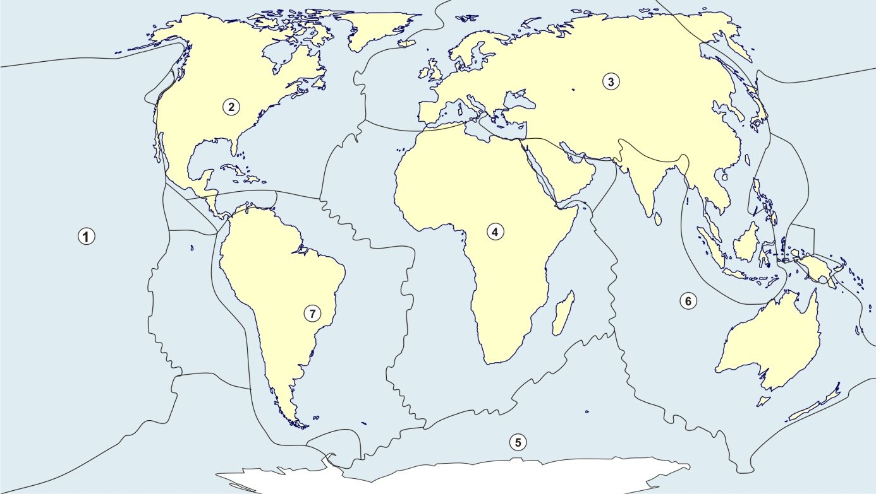

Quelle: WBF 2021; <https://d-maps.com/carte.php?num_car=3266&lang=de>; <https://de.wikipedia.org/wiki/Liste_der_tektonischen_Platten>

|  |  |  |  |  |  |  |  |  |  |  |  |  |  |  |  |  |  |  |  |  |  |  |  |  |
| --- | --- | --- | --- | --- | --- | --- | --- | --- | --- | --- | --- | --- | --- | --- | --- | --- | --- | --- | --- | --- | --- | --- | --- | --- |
|  |  |  |  |  |  |  |  |  |  | **1** |  |  |  |  |  |  |  |  |  |  |  |  |  |  |

|  |  |  |  |  |  |  |  |  |  |  |  |  |  |  |  |  |  |  |  |  |  |  |  |  |
| --- | --- | --- | --- | --- | --- | --- | --- | --- | --- | --- | --- | --- | --- | --- | --- | --- | --- | --- | --- | --- | --- | --- | --- | --- |
|  |  |  | **2** |  |  |  |  |  |  | **4** |  |  |  |  |  |  |  |  |  |  |  |  |  |  |

|  |  |  |  |  |  |  |  |  |  |  |  |  |  |  |  |  |  |  |  |  |  |  |  |  |
| --- | --- | --- | --- | --- | --- | --- | --- | --- | --- | --- | --- | --- | --- | --- | --- | --- | --- | --- | --- | --- | --- | --- | --- | --- |
|  |  |  |  |  | **7** |  |  |  |  |  |  |  |  |  |  |  |  |  |  |  |  |  |  |  |

|  |  |  |  |  |  |  |  |  |  |  |  |  |  |  |  |  |  |  |  |  |  |  |  |  |
| --- | --- | --- | --- | --- | --- | --- | --- | --- | --- | --- | --- | --- | --- | --- | --- | --- | --- | --- | --- | --- | --- | --- | --- | --- |
|  |  |  | **5** |  |  |  |  |  |  |  |  |  |  |  |  |  |  |  |  |  |  |  |  |  |

|  |  |  |  |  |  |  |  |  |  |  |  |  |  |  |  |  |  |  |  |  |  |  |  |  |
| --- | --- | --- | --- | --- | --- | --- | --- | --- | --- | --- | --- | --- | --- | --- | --- | --- | --- | --- | --- | --- | --- | --- | --- | --- |
|  |  |  |  |  |  |  |  |  |  |  |  |  |  |  |  |  | **8** |  |  |  |  |  |  |  |

|  |  |  |  |  |  |  |  |  |  |  |  |  |  |  |  |  |  |  |  |  |  |  |  |  |
| --- | --- | --- | --- | --- | --- | --- | --- | --- | --- | --- | --- | --- | --- | --- | --- | --- | --- | --- | --- | --- | --- | --- | --- | --- |
|  |  |  | **3** |  | - |  | **6** |  |  |  |  |  |  |  |  |  |  |  |  |  |  |  |  |  |

|  |  |  |  |  |  |  |  |  |  |  |  |  |  |  |  |  |  |  |  |  |  |  |  |  |
| --- | --- | --- | --- | --- | --- | --- | --- | --- | --- | --- | --- | --- | --- | --- | --- | --- | --- | --- | --- | --- | --- | --- | --- | --- |
|  |  |  |  |  |  |  |  |  |  |  |  |  |  |  |  | **9** |  |  |  |  |  |  |  |  |

|  |  |  |  |  |  |  |  |  |  |
| --- | --- | --- | --- | --- | --- | --- | --- | --- | --- |
| Lösungs-wort | 1 | 2 | 3 | 4 | 5 | 6 | 7 | 8 | 9 |

**Arbeitsaufträge:**

|  |  |  |
| --- | --- | --- |
| **Kreis_punkt** | 1. | Schreibe die Namen der Platten in die Kästchen. |
|  | 2. | Finde das Lösungswort. |