***Name:*** ................................................................ ***Klasse:*** …………

**1.1.4 Arbeitsblatt: Die 7 größten Erdplatten**

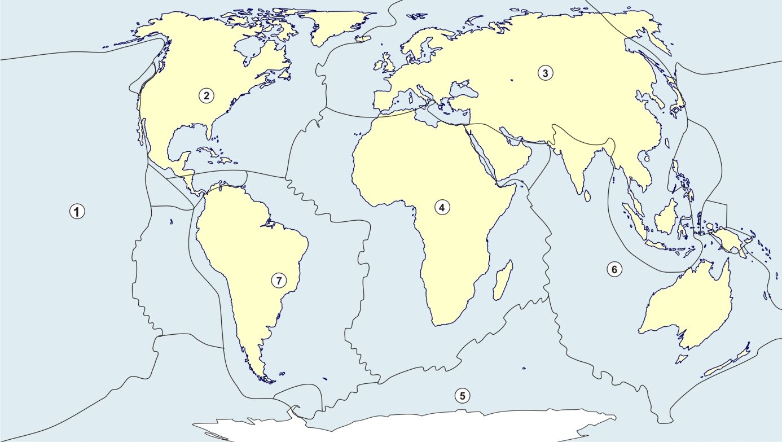

Quelle: WBF 2021; <https://d-maps.com/carte.php?num_car=3266&lang=de>; <https://de.wikipedia.org/wiki/Liste_der_tektonischen_Platten>

|  |  |  |  |  |  |  |  |  |  |  |  |  |  |  |  |  |  |  |  |  |  |  |  |  |
| --- | --- | --- | --- | --- | --- | --- | --- | --- | --- | --- | --- | --- | --- | --- | --- | --- | --- | --- | --- | --- | --- | --- | --- | --- |
|  |  |  |  |  |  |  |  |  |  | **1** |  |  |  |  |  |  |  |  |  |  |  |  |  |  |

|  |  |  |  |  |  |  |  |  |  |  |  |  |  |  |  |  |  |  |  |  |  |  |  |  |
| --- | --- | --- | --- | --- | --- | --- | --- | --- | --- | --- | --- | --- | --- | --- | --- | --- | --- | --- | --- | --- | --- | --- | --- | --- |
|  |  |  | **2** |  |  |  |  |  |  | **4** |  |  |  |  |  |  |  |  |  |  |  |  |  |  |

|  |  |  |  |  |  |  |  |  |  |  |  |  |  |  |  |  |  |  |  |  |  |  |  |  |
| --- | --- | --- | --- | --- | --- | --- | --- | --- | --- | --- | --- | --- | --- | --- | --- | --- | --- | --- | --- | --- | --- | --- | --- | --- |
|  |  |  |  |  | **7** |  |  |  |  |  |  |  |  |  |  |  |  |  |  |  |  |  |  |  |

|  |  |  |  |  |  |  |  |  |  |  |  |  |  |  |  |  |  |  |  |  |  |  |  |  |
| --- | --- | --- | --- | --- | --- | --- | --- | --- | --- | --- | --- | --- | --- | --- | --- | --- | --- | --- | --- | --- | --- | --- | --- | --- |
|  |  |  | **5** |  |  |  |  |  |  |  |  |  |  |  |  |  |  |  |  |  |  |  |  |  |

|  |  |  |  |  |  |  |  |  |  |  |  |  |  |  |  |  |  |  |  |  |  |  |  |  |
| --- | --- | --- | --- | --- | --- | --- | --- | --- | --- | --- | --- | --- | --- | --- | --- | --- | --- | --- | --- | --- | --- | --- | --- | --- |
|  |  |  |  |  |  |  |  |  |  |  |  |  |  |  |  |  | **8** |  |  |  |  |  |  |  |

|  |  |  |  |  |  |  |  |  |  |  |  |  |  |  |  |  |  |  |  |  |  |  |  |  |
| --- | --- | --- | --- | --- | --- | --- | --- | --- | --- | --- | --- | --- | --- | --- | --- | --- | --- | --- | --- | --- | --- | --- | --- | --- |
|  |  |  | **3** |  | - |  | **6** |  |  |  |  |  |  |  |  |  |  |  |  |  |  |  |  |  |

|  |  |  |  |  |  |  |  |  |  |  |  |  |  |  |  |  |  |  |  |  |  |  |  |  |
| --- | --- | --- | --- | --- | --- | --- | --- | --- | --- | --- | --- | --- | --- | --- | --- | --- | --- | --- | --- | --- | --- | --- | --- | --- |
|  |  |  |  |  |  |  |  |  |  |  |  |  |  |  |  | **9** |  |  |  |  |  |  |  |  |

|  |  |  |  |  |  |  |  |  |  |
| --- | --- | --- | --- | --- | --- | --- | --- | --- | --- |
| Lösungs-wort | 1 | 2 | 3 | 4 | 5 | 6 | 7 | 8 | 9 |

**Arbeitsaufträge:**

|  |  |  |
| --- | --- | --- |
| **Kreis_punkt** | 1. | Schreibe die Namen der Platten in die Kästchen. |
|  | 2. | Finde das Lösungswort. |

**Lösungen:**

|  |  |  |  |  |  |  |  |  |  |  |  |  |  |  |  |  |  |  |  |  |  |  |  |  |
| --- | --- | --- | --- | --- | --- | --- | --- | --- | --- | --- | --- | --- | --- | --- | --- | --- | --- | --- | --- | --- | --- | --- | --- | --- |
|  | P | a | z | i | f | i | s | c | h | **1**  e |  | P | l | a | t | t | e |  |  |  |  |  |  |  |

|  |  |  |  |  |  |  |  |  |  |  |  |  |  |  |  |  |  |  |  |  |  |  |  |  |
| --- | --- | --- | --- | --- | --- | --- | --- | --- | --- | --- | --- | --- | --- | --- | --- | --- | --- | --- | --- | --- | --- | --- | --- | --- |
|  | N | o | **2**  r | d | a | m | e | r | i | **4**  k | a | n | i | s | c | h | e |  | P | l | a | t | t | e |

|  |  |  |  |  |  |  |  |  |  |  |  |  |  |  |  |  |  |  |  |  |  |  |  |  |
| --- | --- | --- | --- | --- | --- | --- | --- | --- | --- | --- | --- | --- | --- | --- | --- | --- | --- | --- | --- | --- | --- | --- | --- | --- |
|  | E | u | r | a | **7**  s | i | s | c | h | e |  | P | l | a | t | t | e |  |  |  |  |  |  |  |

|  |  |  |  |  |  |  |  |  |  |  |  |  |  |  |  |  |  |  |  |  |  |  |  |  |
| --- | --- | --- | --- | --- | --- | --- | --- | --- | --- | --- | --- | --- | --- | --- | --- | --- | --- | --- | --- | --- | --- | --- | --- | --- |
|  | A | f | **5**  r | i | k | a | n | i | s | c | h | e |  | P | l | a | t | t | e |  |  |  |  |  |

|  |  |  |  |  |  |  |  |  |  |  |  |  |  |  |  |  |  |  |  |  |  |  |  |  |
| --- | --- | --- | --- | --- | --- | --- | --- | --- | --- | --- | --- | --- | --- | --- | --- | --- | --- | --- | --- | --- | --- | --- | --- | --- |
|  | A | n | t | a | r | k | t | i | s | c | h | e |  | P | l | a | **8**  t | t | e |  |  |  |  |  |

|  |  |  |  |  |  |  |  |  |  |  |  |  |  |  |  |  |  |  |  |  |  |  |  |  |
| --- | --- | --- | --- | --- | --- | --- | --- | --- | --- | --- | --- | --- | --- | --- | --- | --- | --- | --- | --- | --- | --- | --- | --- | --- |
|  | I | n | **3**  d | o | - | A | **6**  u | s | t | r | a | l | i | s | c | h | e |  | P | l | a | t | t | e |

|  |  |  |  |  |  |  |  |  |  |  |  |  |  |  |  |  |  |  |  |  |  |  |  |  |
| --- | --- | --- | --- | --- | --- | --- | --- | --- | --- | --- | --- | --- | --- | --- | --- | --- | --- | --- | --- | --- | --- | --- | --- | --- |
|  | S | ü | d | a | m | e | r | i | k | a | n | i | s | c | h | **9**  e |  | P | l | a | t | t | e |  |

|  |  |  |  |  |  |  |  |  |  |
| --- | --- | --- | --- | --- | --- | --- | --- | --- | --- |
| Lösungs- wort | 1  E | 2  r | 3  d | 4  k | 5  r | 6  u | 7  s | 8  t | 9  e |

Quelle: WBF 2021; <https://d-maps.com> ; <https://www.usgs.gov/natural-hazards/earthquake-hazards/science/20-largest-earthquakes-world?qt-science_center_objects=0#qt-science_center_objects>

***Name:***................................................................ ***Klasse:*** ……………

**2.1.4 Arbeitsblatt: Die 10 stärksten Erdbeben der Welt**

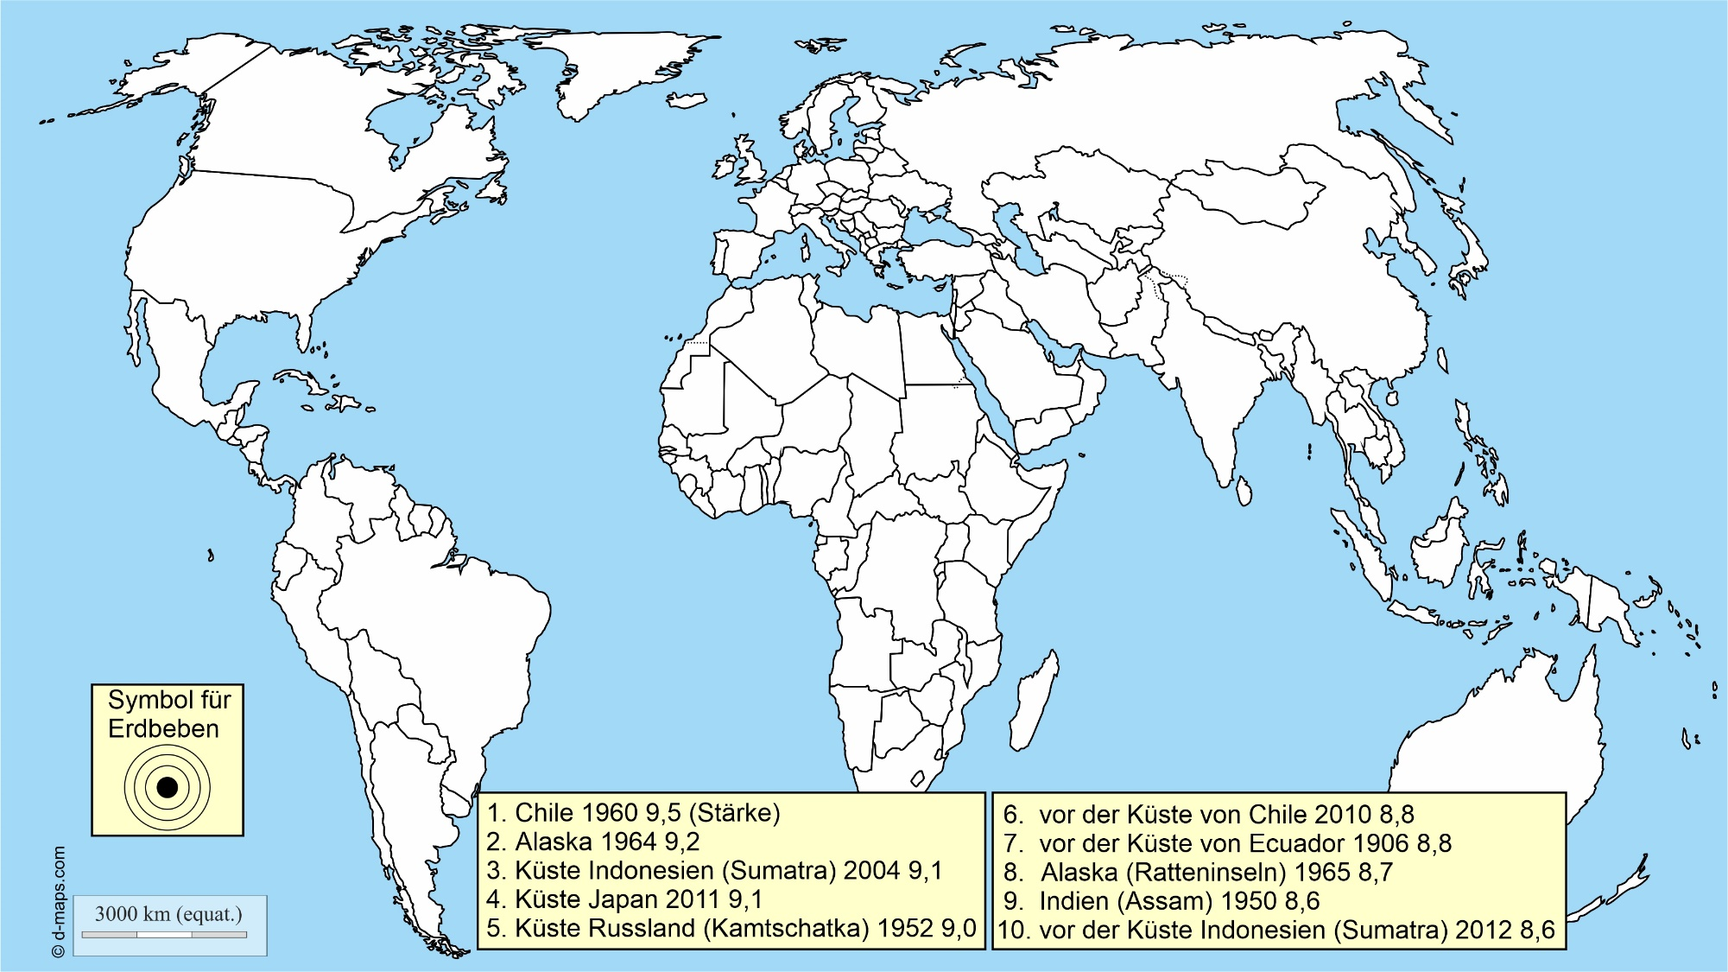

**Arbeitsaufträge:**

|  |  |
| --- | --- |
|  | Trage die Erdbeben mit einer Ziffer und dem Symbol für Erdbeben an die richtige Stelle in der Karte ein. |
|  | Informiere dich im Internet über die Stärke von Erdbeben auf der Richterskala. |

**Lösungen:**

**Zu ➀:**

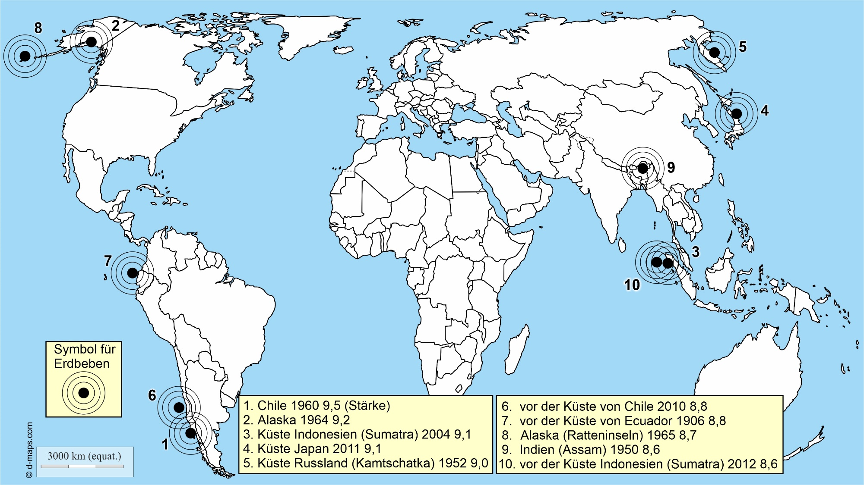

**Zu ➁:** Individuelle Bearbeitung

***Name:*** ................................................................ ***Klasse:*** …………

**3.1.2 Arbeitsblatt: Vulkanisches Material bei einem Vulkanausbruch**

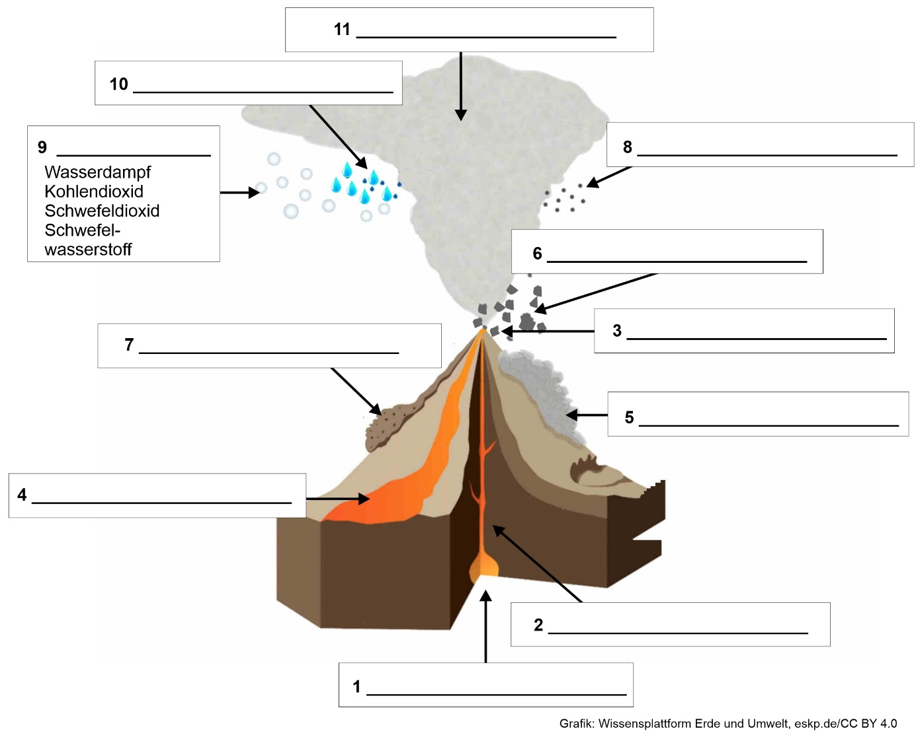

Quelle: WBF 2021; eskp.de | Earth System Knowledge Platform - die Wissensplattform des For-schungsbereichs Erde und Umwelt der Helmholtz-Gemeinschaft

Grafik: Wissensplattform Erde und Umwelt, <https://www.eskp.de/grundlagen/naturgefahren/vulkane-eruptionsprodukte-935409/> Änderungen: Erläuterung/Beschriftung vereinfacht / CC BY 4.0

**Arbeitsauftrag:**

|  |
| --- |
| Schreibe die Begriffe in die entsprechenden Kästchen des Schaubilds.  Ascheregen - Eruptionswolke - Förderschlot - Gase - Gesteinsbrocken - Glutlawine - Krater - Lava - Magmakammer - Säureregen - Schlammstrom |

**Lösung:**

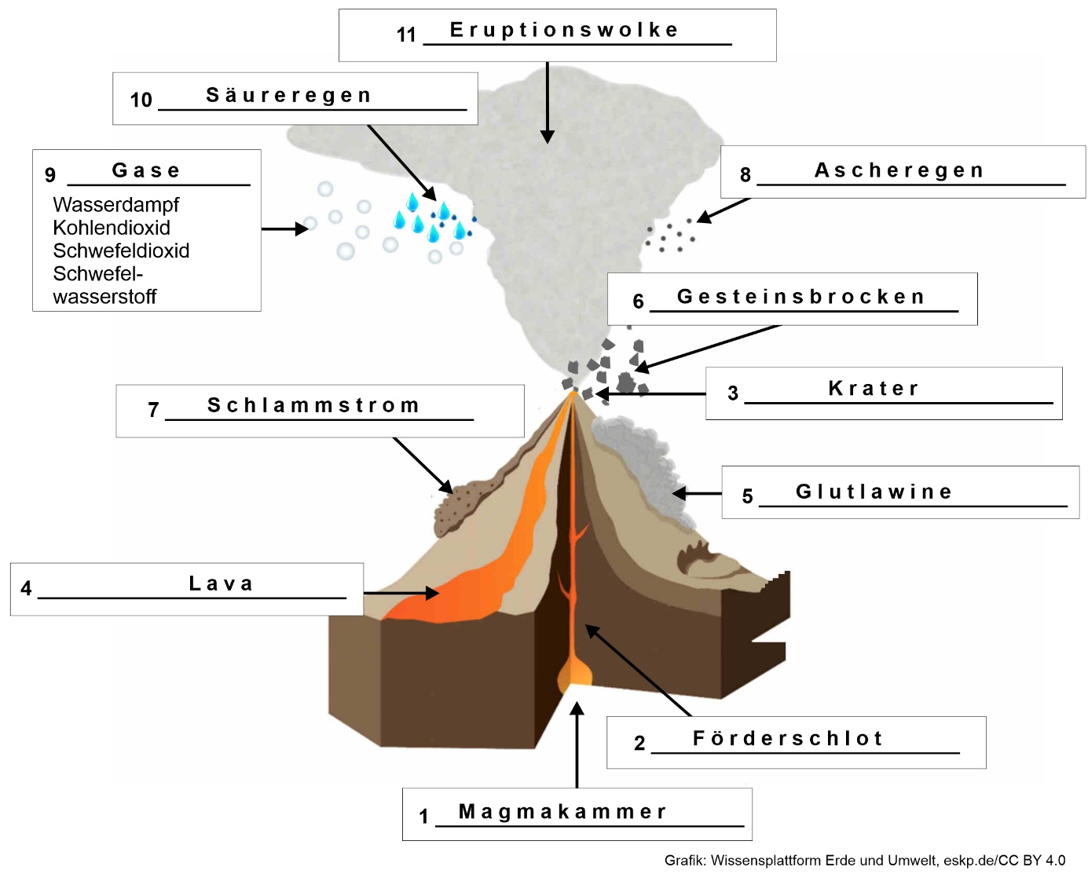

***Name:*** ................................................................ ***Klasse:*** ……………

**3.1.4 Arbeitsblatt: Die 10 risikoreichsten Vulkane der Welt**

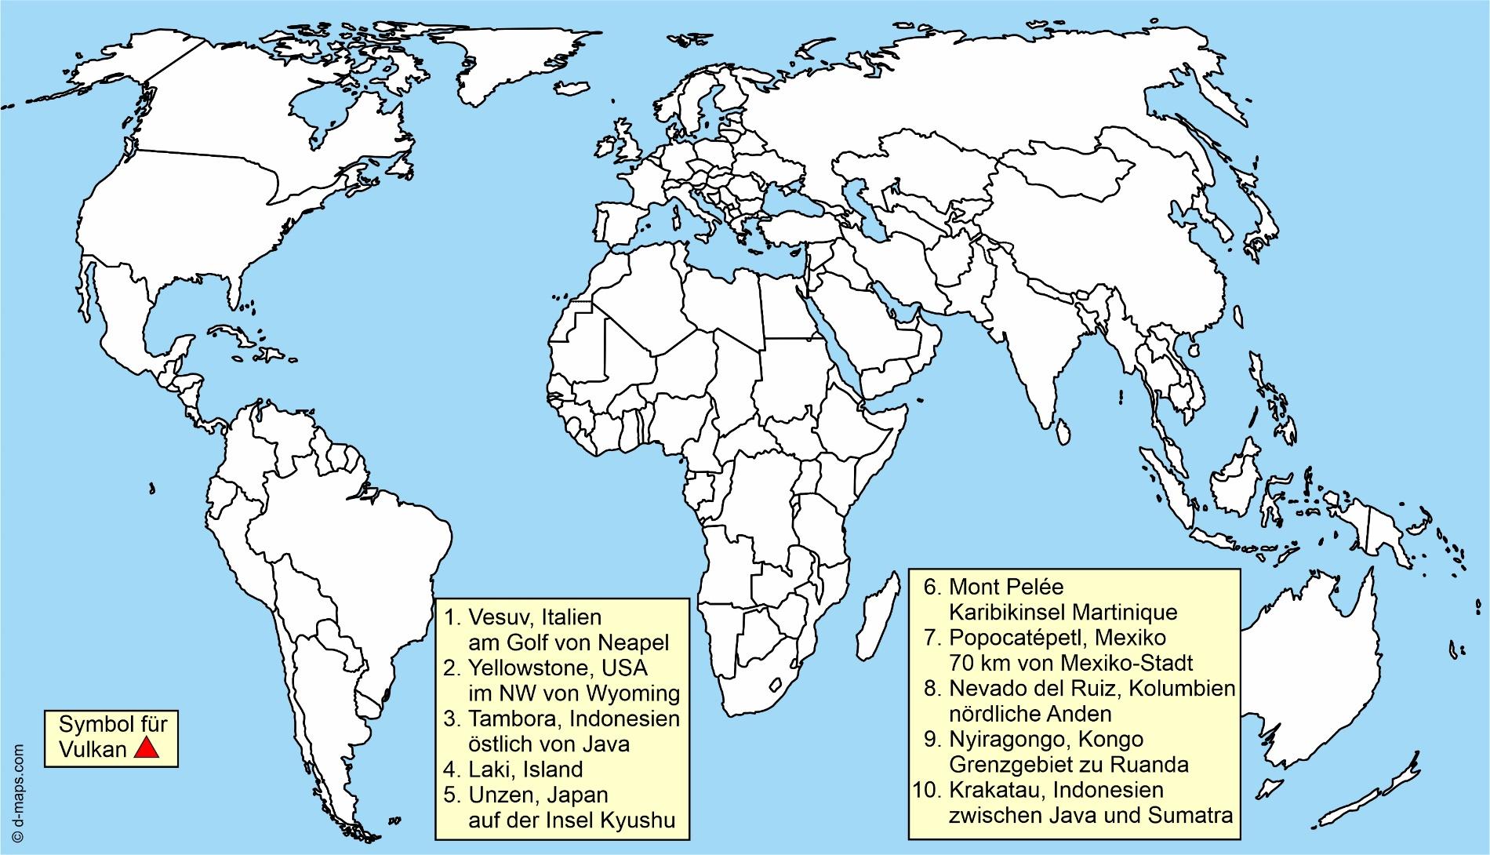

WBT 2021: <https://www.spektrum.de/wissen/10-lebensgefaehrliche-vulkane-der-erde/1340358/>

**Arbeitsaufträge:**

|  |  |
| --- | --- |
|  | Trage die Vulkane mit einer Ziffer und dem Symbol für Vulkan in die Karte ein. Benutze dazu auch den Atlas. |
|  | Informiere dich im Internet unter <https://volcano.si.edu/reports_weekly.cfm> über vulkanische Aktivitäten in dieser Woche.  Trage mindestens fünf Vulkane in die Weltkarte ein. |

**Lösungen:**

Zu ➀

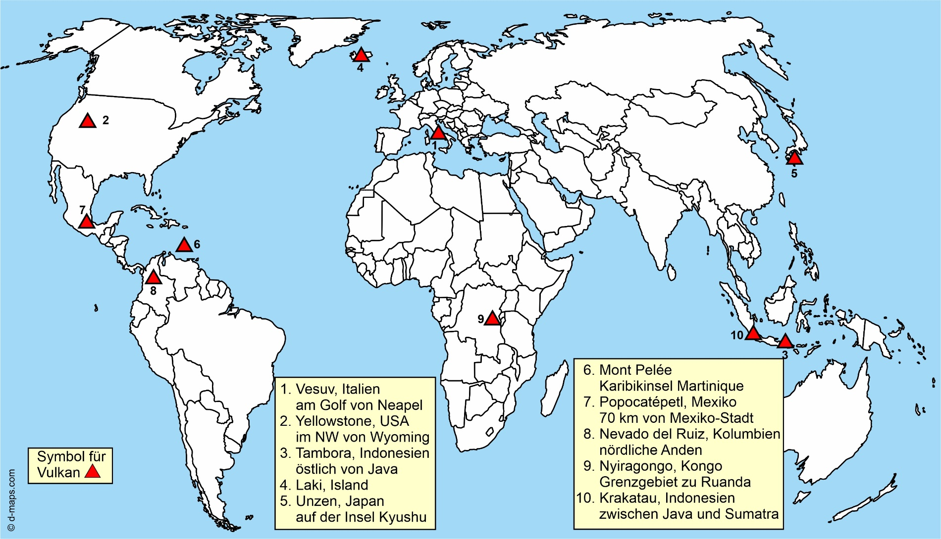

Zu ➁: Individuelle Lösung

***Name:*** ................................................................ ***Klasse:*** …………

**4.1.1 Arbeitsblatt: Die wichtigsten Faltengebirge**

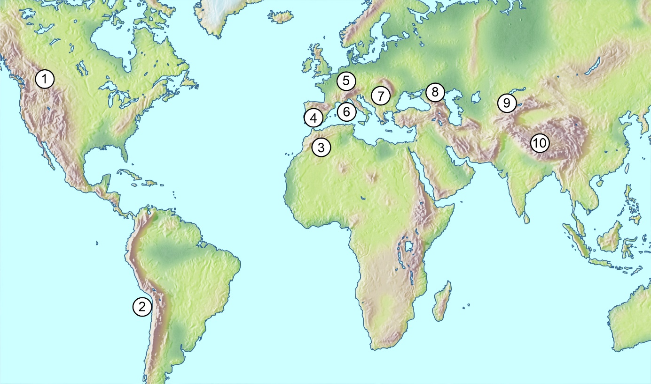

Quelle: WBF 2021; Physische Karte, verschiedene Atlanten  
Kartenvorlage: Mountain High Maps® Copyright © 1993 Digital Wisdom®, Inc.

|  |  |  |  |  |  |  |  |  |  |  |  |  |  |  |  |  |  |  |  |  |  |  |  |  |
| --- | --- | --- | --- | --- | --- | --- | --- | --- | --- | --- | --- | --- | --- | --- | --- | --- | --- | --- | --- | --- | --- | --- | --- | --- |
|  |  |  | c |  |  |  |  |  |  |  | **4** |  |  |  |  |  |  |  |  |  |  |  |  |  |

|  |  |  |  |  |  |  |  |  |  |  |  |  |  |  |  |  |  |  |  |  |  |  |  |  |
| --- | --- | --- | --- | --- | --- | --- | --- | --- | --- | --- | --- | --- | --- | --- | --- | --- | --- | --- | --- | --- | --- | --- | --- | --- |
|  |  |  |  | **6** |  |  |  |  |  |  |  |  |  | **5** | **2** |  |  |  |  | **8** |  |  |  | **11** |

|  |  |  |  |  |  |  |  |  |  |  |  |  |  |  |  |  |  |  |  |  |  |  |  |  |
| --- | --- | --- | --- | --- | --- | --- | --- | --- | --- | --- | --- | --- | --- | --- | --- | --- | --- | --- | --- | --- | --- | --- | --- | --- |
|  | **1** |  |  |  |  |  |  |  |  |  |  |  |  |  |  | **9** |  |  |  |  |  |  |  |  |

|  |  |  |  |  |  |  |  |  |  |  |  |  |  |  |  |  |  |  |  |  |  |  |  |  |
| --- | --- | --- | --- | --- | --- | --- | --- | --- | --- | --- | --- | --- | --- | --- | --- | --- | --- | --- | --- | --- | --- | --- | --- | --- |
|  |  |  |  |  | **7** |  |  |  |  |  |  |  |  |  |  |  |  | **15** |  |  |  |  | **12** |  |

|  |  |  |  |  |  |  |  |  |  |  |  |  |  |  |  |  |  |  |  |  |  |  |  |  |
| --- | --- | --- | --- | --- | --- | --- | --- | --- | --- | --- | --- | --- | --- | --- | --- | --- | --- | --- | --- | --- | --- | --- | --- | --- |
|  |  |  |  |  |  |  |  |  |  |  |  |  |  | **14** |  |  |  | **13** |  |  |  |  |  |  |

|  |  |  |  |  |  |  |  |  |  |  |  |  |  |  |  |  |  |  |  |  |  |  |  |  |
| --- | --- | --- | --- | --- | --- | --- | --- | --- | --- | --- | --- | --- | --- | --- | --- | --- | --- | --- | --- | --- | --- | --- | --- | --- |
|  |  |  |  |  |  |  |  | **3** |  |  |  |  |  |  |  |  |  |  |  |  |  |  |  |  |

|  |  |  |  |  |  |  |  |  |  |  |  |  |  |  |  |
| --- | --- | --- | --- | --- | --- | --- | --- | --- | --- | --- | --- | --- | --- | --- | --- |
| Lösungswort | **1** | **2** | **3** | **4** | **5** | **6** | **7** | **8** | **9** | **10**  **w** | **11** | **12** | **13** | **14** | **15** |

**Arbeitsaufträge:**

|  |  |  |
| --- | --- | --- |
| **Kreis_punkt** | 1. | Schreibe die Namen der Faltengebirge in die Kästchen. |
|  | 2. | Finde das Lösungswort. |

**Lösung:**

|  |  |  |  |  |  |  |  |  |  |  |  |  |  |  |  |  |  |  |  |  |  |  |  |  |
| --- | --- | --- | --- | --- | --- | --- | --- | --- | --- | --- | --- | --- | --- | --- | --- | --- | --- | --- | --- | --- | --- | --- | --- | --- |
|  |  |  |  |  |  |  |  |  |  |  | **4** |  |  |  |  |  |  |  |  |  |  |  |  |  |
|  | R | o | c | k | y |  | M | o | u | n | t | a | i | n | s |  |  |  |  |  |  |  |  |  |

|  |  |  |  |  |  |  |  |  |  |  |  |  |  |  |  |  |  |  |  |  |  |  |  |  |
| --- | --- | --- | --- | --- | --- | --- | --- | --- | --- | --- | --- | --- | --- | --- | --- | --- | --- | --- | --- | --- | --- | --- | --- | --- |
|  |  |  |  | **6** |  |  |  |  |  |  |  |  |  | **5** | **2** |  |  |  |  | **8** |  |  |  | **11** |
|  | A | n | d | e | n |  |  |  |  |  |  |  | A | t | l | a | s | g | e | b | i | r | g | e |

|  |  |  |  |  |  |  |  |  |  |  |  |  |  |  |  |  |  |  |  |  |  |  |  |  |
| --- | --- | --- | --- | --- | --- | --- | --- | --- | --- | --- | --- | --- | --- | --- | --- | --- | --- | --- | --- | --- | --- | --- | --- | --- |
|  | **1** |  |  |  |  |  |  |  |  |  |  |  |  |  |  | **9** |  |  |  |  |  |  |  |  |
|  | P | y | r | e | n | ä | e | n |  |  |  |  | A | l | p | e | n |  |  |  |  |  |  |  |

|  |  |  |  |  |  |  |  |  |  |  |  |  |  |  |  |  |  |  |  |  |  |  |  |  |
| --- | --- | --- | --- | --- | --- | --- | --- | --- | --- | --- | --- | --- | --- | --- | --- | --- | --- | --- | --- | --- | --- | --- | --- | --- |
|  |  |  |  |  | **7** |  |  |  |  |  |  |  |  |  |  |  |  | **15** |  |  |  |  | **12** |  |
|  | A | p | e | n | n | i | n |  |  |  |  | B | a | l | k | a | n | g | e | b | i | r | g | e |

|  |  |  |  |  |  |  |  |  |  |  |  |  |  |  |  |  |  |  |  |  |  |  |  |  |
| --- | --- | --- | --- | --- | --- | --- | --- | --- | --- | --- | --- | --- | --- | --- | --- | --- | --- | --- | --- | --- | --- | --- | --- | --- |
|  |  |  |  |  |  |  |  |  |  |  |  |  |  | **14** |  |  |  | **13** |  |  |  |  |  |  |
|  | K | a | u | k | a | s | u | s |  |  |  | H | i | n | d | u | k | u | s | c | h |  |  |  |

|  |  |  |  |  |  |  |  |  |  |  |  |  |  |  |  |  |  |  |  |  |  |  |  |  |
| --- | --- | --- | --- | --- | --- | --- | --- | --- | --- | --- | --- | --- | --- | --- | --- | --- | --- | --- | --- | --- | --- | --- | --- | --- |
|  |  |  |  |  |  |  |  | **3** |  |  |  |  |  |  |  |  |  |  |  |  |  |  |  |  |
|  | H | i | m | a | l | a | y | a |  |  |  |  |  |  |  |  |  |  |  |  |  |  |  |  |

|  |  |  |  |  |  |  |  |  |  |  |  |  |  |  |  |  |
| --- | --- | --- | --- | --- | --- | --- | --- | --- | --- | --- | --- | --- | --- | --- | --- | --- |
| Lösungswort |  | **1** | **2** | **3** | **4** | **5** | **6** | **7** | **8** | **9** | **10** | **11** | **12** | **13** | **14** | **15** |
|  | **P** | **l** | **a** | **t** | **t** | **e** | **n** | **b** | **e** | **w** | **e** | **g** | **u** | **n** | **g** |

***Name: ………………….……………………………. Klasse/Lerngruppe: ……..…………***

**4.1.2 Arbeitsblatt: Wie ein Faltengebirge entsteht**

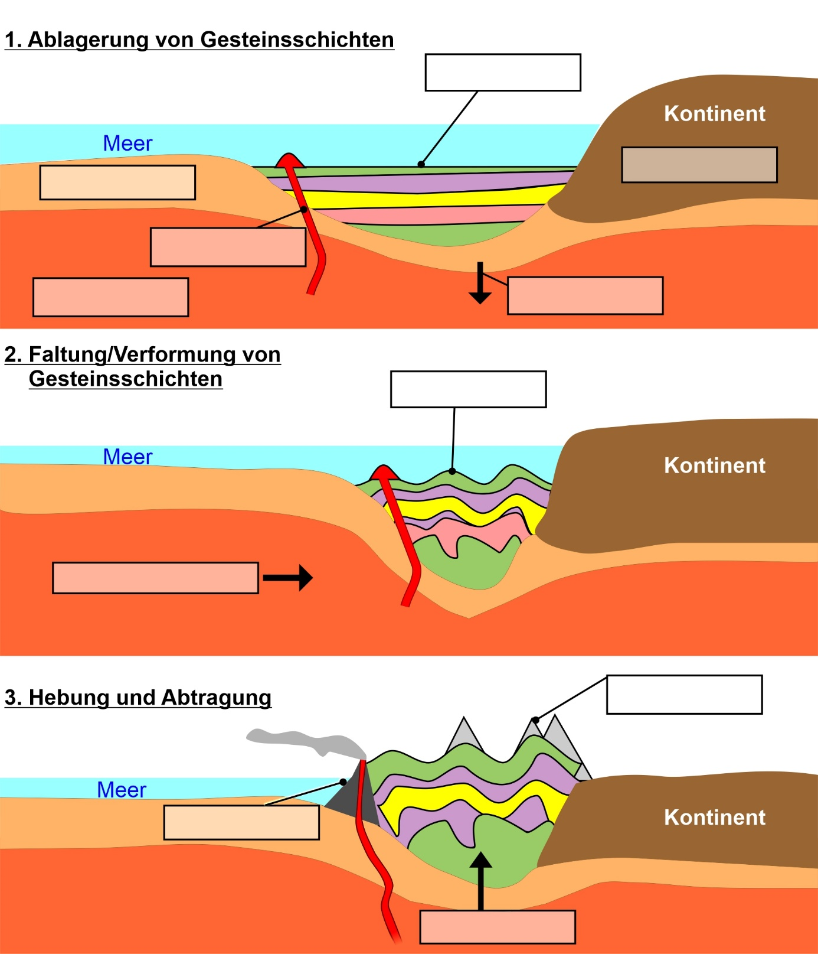

Quelle: WBF 2021; <https://de.wikipedia.org/wiki/Faltengebirge>; <https://de.wikipedia.org/wiki/Gebirgsbildung>; <https://slideplayer.org/slide/913572/>

Zeichnung nach: Mensch und Raum Geographie 9/10 SH, Handreichungen für den Unterricht, Cornelsen

**Arbeitsauftrag:**

|  |
| --- |
| Beschrifte die Abbildungen mit den unten genannten Begriffen. |

Ablagerung (2x) - Abtragung - Bewegungsrichtung - Erdmantel - Hebung - Vulkan -  
obere Kruste - Senkung - untere Kruste - Magma

**Lösung:**

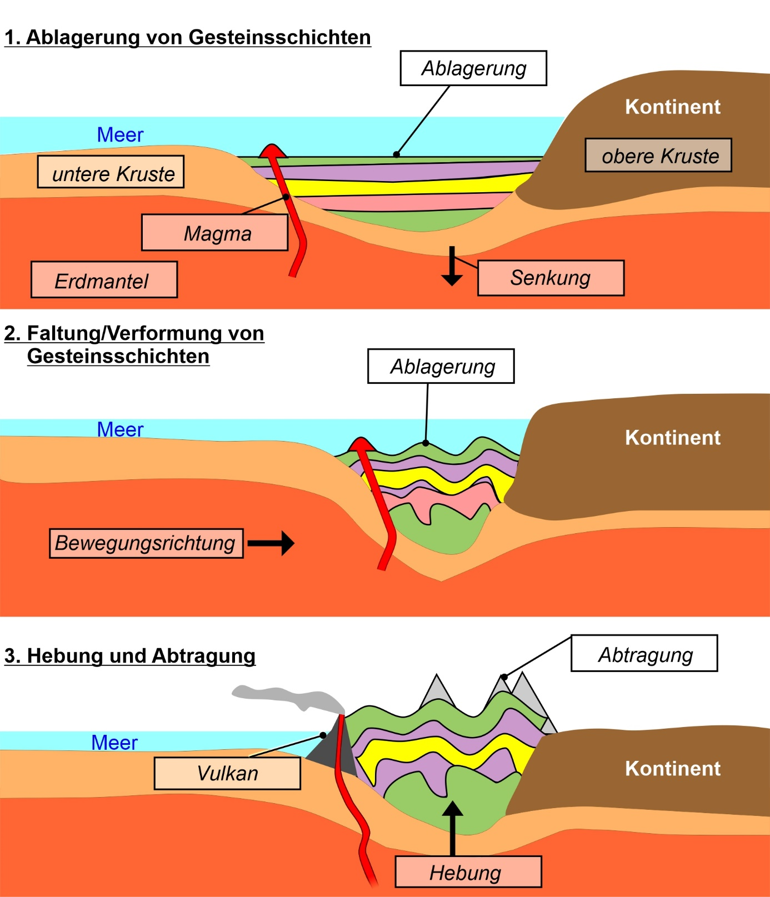

***Name:*** ................................................................ ***Klasse:*** …………

**4.1.4 Arbeitsblatt: Endogene Kräfte formen Hochgebirge**

|  |  |  |
| --- | --- | --- |
|  |  |  |

|  |  |  |
| --- | --- | --- |
| Trifft eine ozeanische Platte auf eine kontinentale Platte, sinkt die ozeanische Platte ab. Sie schiebt sich unter die konti-nentale Platte. Die abtauchende Platte wird aufgeheizt. Das dabei entstehende Magma steigt auf. So entstehen langgestreckte Vulkanketten auf der kontinentalen Platte. |  | Wenn sich zwei kontinentale Platten frontal treffen, taucht keine von beiden ab. Sie widerstehen wie zwei Eisberge, die zusammenstoßen, der Abwärtsbewegung. Stattdessen knickt die Kruste oder wird nach oben oder zur Seite gedrückt. Es kommt zur Hebung der Kruste mit Gebirgsbildung. |

|  |  |  |
| --- | --- | --- |
| ➄  414 Bild 5 |  | ➅  414 Bild 6 |

** Alpen  Anden  Matterhorn  Maipo Canyon (Chile)**

|  |  |  |
| --- | --- | --- |
|  |  |  |

Quelle: WBF 2021; Shutterstock (Fotos); Pixabay (Karten)

Grafik: <https://www.eskp.de/naturgefahren/vulkanismus/>

**Arbeitsauftrag:**

|  |  |
| --- | --- |
| ▶ | Bringe die einzelnen Elemente in zwei Spalten richtig zusammen. In jede Spalte gehören untereinander die Karte, der Gebirgsname, das Foto, der Name des Berges, die Grafik und der Text. Beginne mit der Karte der Alpen. |

**Lösung:**

|  |  |  |
| --- | --- | --- |
|  |  |  |
| **Alpen** |  | **Anden** |

|  |  |  |
| --- | --- | --- |
|  |  |  |
| **Matterhorn** |  | **Maipo Canyon (Chile)** |

|  |  |  |
| --- | --- | --- |
| ➄  414 Bild 5 |  | ➅  **414 Bild 6** |

|  |  |  |
| --- | --- | --- |
| Wenn sich zwei kontinentale Platten frontal treffen, taucht keine von beiden ab. Sie widerstehen wie zwei Eisberge, die zusammenstoßen, der Abwärtsbewegung. Stattdessen knickt die Kruste oder wird nach oben oder zur Seite gedrückt. Es kommt zur Hebung der Kruste mit Gebirgsbildung. |  | Trifft eine ozeanische Platte auf eine kontinentale Platte, sinkt die ozeanische Platte ab. Sie schiebt sich unter die konti-nentale Platte. Die abtauchende Platte wird aufgeheizt. Das dabei entstehende Magma steigt auf. So entstehen langgestreckte Vulkanketten auf der kontinentalen Platte. |